TASK 2 – DEEP LEARNING
1. OBJECTIVE
- To develop a deep learning model for binary classification.
- To use the Breast Cancer Wisconsin dataset for classification.
- To preprocess and scale the input features.
- To build a neural network using TensorFlow and Keras.
- To train the model and evaluate its performance.
- To classify samples into malignant and benign categories.
- To analyze the model using accuracy, classification report, and confusion matrix.
2. PROJECT DESCRIPTION
This project implements a Deep Learning-based classification system using a neural network. The Breast Cancer Wisconsin dataset is used for training and testing the model.
The dataset contains 569 samples and 30 numerical features. The target variable consists of two classes: malignant and benign.
The dataset is divided into training and testing sets. 455 samples are used for training and 114 samples are used for testing. Feature scaling is performed using StandardScaler to normalize the input data before training the neural network.
A Sequential neural network is developed using TensorFlow and Keras. The model contains multiple Dense layers with ReLU activation and Dropout layers to help reduce overfitting. The final Dense layer uses a sigmoid activation function for binary classification.
The model is compiled using the Adam optimizer and binary cross-entropy loss function. It is trained for 30 epochs with a batch size of 32.
Model Architecture
- Input layer: 30 features
- Dense layer: 64 neurons
- Dropout: 20%
- Dense layer: 32 neurons
- Dropout: 20%
- Dense layer: 16 neurons
- Output layer: 1 neuron
- Activation function in hidden layers: ReLU
- Activation function in output layer: Sigmoid
- Total parameters: 4,609
- Trainable parameters: 4,609
Training Results
The model was trained for 30 epochs. During training, the accuracy gradually improved.
At the final epoch:
- Training Accuracy: 99.18%
- Training Loss: 0.0272
- Validation Accuracy: 100%
- Validation Loss: 0.0266
Model Evaluation
The trained model achieved:
- Test Loss: 0.1076
- Test Accuracy: 95.61%
Classification Report
Class | Precision | Recall | F1-Score | Support
Malignant | 0.93 | 0.95 | 0.94 | 42
Benign | 0.97 | 0.96 | 0.97 | 72
Accuracy |  |  | 0.96 | 114
Macro Average | 0.95 | 0.96 | 0.95 | 114
Weighted Average | 0.96 | 0.96 | 0.96 | 114
Confusion Matrix
The confusion matrix obtained from the model is:
[[40 2]
[ 3 69]]
This indicates that the model correctly classified 40 malignant and 69 benign samples, while a small number of samples were incorrectly classified.

Sample Prediction
The model generated the following sample prediction:
Predicted Class: malignant
Prediction Probability: 0.0
Actual Class: malignant
The model was successfully saved as:
task2_deep_learning_model.keras
Technologies Used
- Python
- TensorFlow 2.20.0
- Keras
- NumPy
- Pandas
- Scikit-learn
- Matplotlib
- Google Colab
3. PROJECT SCREENSHOTS
1 – Dataset Information
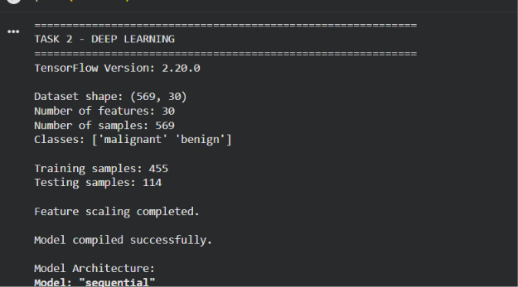
Include the output showing:
TensorFlow Version: 2.20.0
Dataset shape: (569, 30)
Number of features: 30
Number of samples: 569
Classes: ['malignant' 'benign']
Training samples: 455
Testing samples: 114

2 – Model Architecture
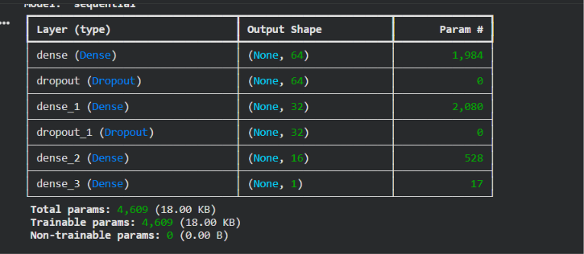
Include the Keras model summary showing the Dense and Dropout layers and:
Total params: 4,609
Trainable params: 4,609

3 – Model Training
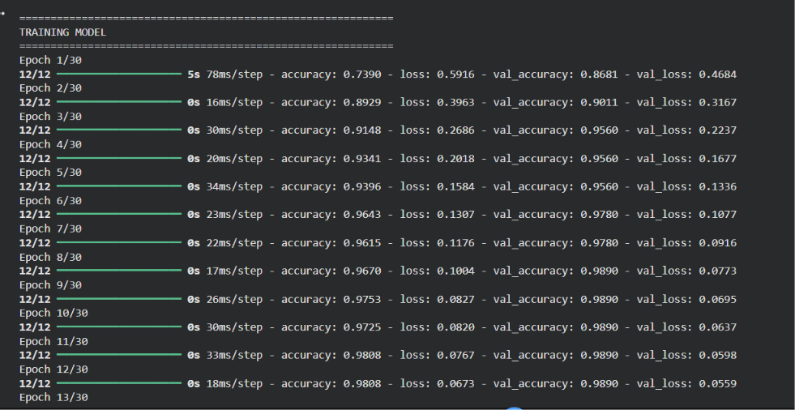
Include the training output from:
Epoch 1/30
to:
Epoch 30/30
You don't necessarily need to put all 30 epochs as separate screenshots. One screenshot showing the training output clearly is enough.

4 – Model Evaluation
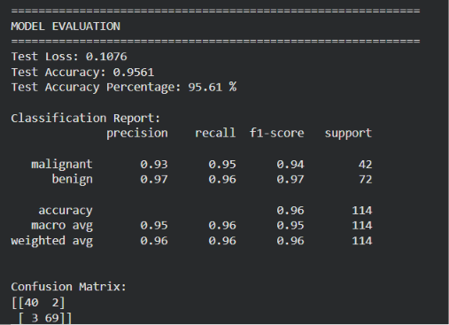
Include:
Test Loss: 0.1076
Test Accuracy: 0.9561
Test Accuracy Percentage: 95.61 %

5 – Classification Report
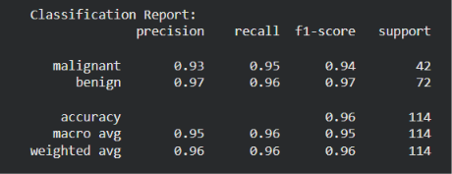

Include the complete classification report.

6 – Confusion Matrix
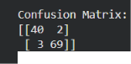
Include:
[[40 2]
[ 3 69]]

7 – Training and Validation Accuracy
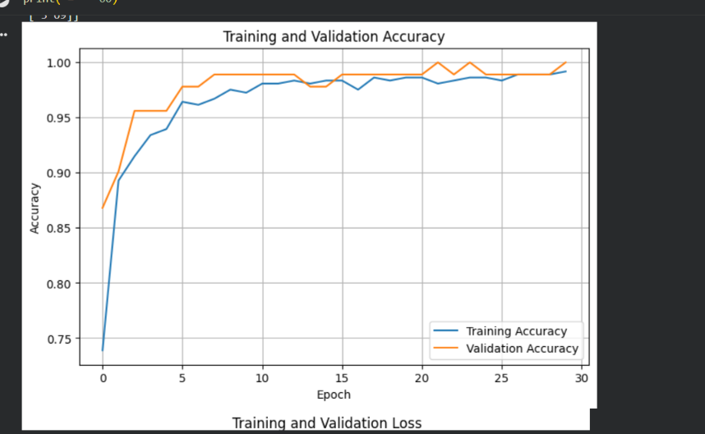
Include the Training and Validation Accuracy graph generated by your code.

8 – Training and Validation Loss
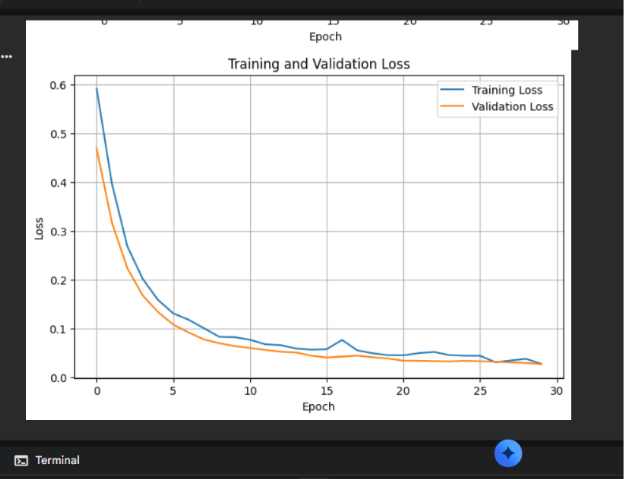
Include the Training and Validation Loss graph generated by your code.

9 – Sample Prediction
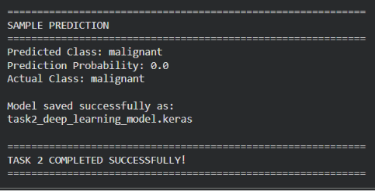
Include:
Predicted Class: malignant
Prediction Probability: 0.0
Actual Class: malignant

4. CODE SNIPPETS
# ============================================================
# TASK 2 - DEEP LEARNING
# Breast Cancer Classification using Neural Network
# ============================================================

# 1. Import libraries
import numpy as np
import pandas as pd
import matplotlib.pyplot as plt
import tensorflow as tf

from sklearn.datasets import load_breast_cancer
from sklearn.model_selection import train_test_split
from sklearn.preprocessing import StandardScaler
from sklearn.metrics import (
accuracy_score,
classification_report,
confusion_matrix
)

print("=" * 60)
print("TASK 2 - DEEP LEARNING")
print("=" * 60)

print("TensorFlow Version:", tf.__version__)

# 2. Load dataset
data = load_breast_cancer()

X = data.data
y = data.target

print("\nDataset shape:", X.shape)
print("Number of features:", X.shape[1])
print("Number of samples:", X.shape[0])
print("Classes:", data.target_names)

# 3. Split dataset
X_train, X_test, y_train, y_test = train_test_split(
X,
y,
test_size=0.20,
random_state=42,
stratify=y
)

print("\nTraining samples:", X_train.shape[0])
print("Testing samples:", X_test.shape[0])

# 4. Feature scaling
scaler = StandardScaler()

X_train = scaler.fit_transform(X_train)
X_test = scaler.transform(X_test)

print("\nFeature scaling completed.")

# 5. Build Deep Learning model
model = tf.keras.Sequential([
tf.keras.layers.Input(shape=(30,)),

tf.keras.layers.Dense(
64,
activation="relu"
),

tf.keras.layers.Dropout(0.2),

tf.keras.layers.Dense(
32,
activation="relu"
),

tf.keras.layers.Dropout(0.2),

tf.keras.layers.Dense(
16,
activation="relu"
),

tf.keras.layers.Dense(
1,
activation="sigmoid"
)
])

# 6. Compile model
model.compile(
optimizer="adam",
loss="binary_crossentropy",
metrics=["accuracy"]
)

print("\nModel compiled successfully.")

print("\nModel Architecture:")
model.summary()

# 7. Train model
print("\n" + "=" * 60)
print("TRAINING MODEL")
print("=" * 60)

history = model.fit(
X_train,
y_train,
epochs=30,
batch_size=32,
validation_split=0.2,
verbose=1
)

# 8. Evaluate model
print("\n" + "=" * 60)
print("MODEL EVALUATION")
print("=" * 60)

test_loss, test_accuracy = model.evaluate(
X_test,
y_test,
verbose=0
)

print("Test Loss:", round(test_loss, 4))
print("Test Accuracy:", round(test_accuracy, 4))
print(
"Test Accuracy Percentage:",
round(test_accuracy * 100, 2),
"%"
)

# 9. Predictions
y_probability = model.predict(
X_test,
verbose=0
)

y_pred = (
y_probability > 0.5
).astype(int).flatten()

# 10. Classification report
print("\nClassification Report:")

print(
classification_report(
y_test,
y_pred,
target_names=data.target_names
)
)

# 11. Confusion matrix
print("\nConfusion Matrix:")

cm = confusion_matrix(
y_test,
y_pred
)

print(cm)

# 12. Plot training and validation accuracy
plt.figure(figsize=(8, 5))

plt.plot(
history.history["accuracy"],
label="Training Accuracy"
)

plt.plot(
history.history["val_accuracy"],
label="Validation Accuracy"
)

plt.title("Training and Validation Accuracy")
plt.xlabel("Epoch")
plt.ylabel("Accuracy")
plt.legend()
plt.grid(True)
plt.show()

# 13. Plot training and validation loss
plt.figure(figsize=(8, 5))

plt.plot(
history.history["loss"],
label="Training Loss"
)

plt.plot(
history.history["val_loss"],
label="Validation Loss"
)

plt.title("Training and Validation Loss")
plt.xlabel("Epoch")
plt.ylabel("Loss")
plt.legend()
plt.grid(True)
plt.show()

# 14. Sample prediction
sample = X_test[:1]

prediction_probability = model.predict(
sample,
verbose=0
)[0][0]

prediction = int(
prediction_probability > 0.5
)

print("\n" + "=" * 60)
print("SAMPLE PREDICTION")
print("=" * 60)

print(
"Predicted Class:",
data.target_names[prediction]
)

print(
"Prediction Probability:",
round(float(prediction_probability), 4)
)

print(
"Actual Class:",
data.target_names[y_test[0]]
)

# 15. Save model
model.save(
"task2_deep_learning_model.keras"
)

print("\nModel saved successfully as:")
print("task2_deep_learning_model.keras")

print("\n" + "=" * 60)
print("TASK 2 COMPLETED SUCCESSFULLY!")
print("=" * 60)
CONCLUSION
The Deep Learning classification project was successfully implemented using TensorFlow and Keras. The neural network was trained on the Breast Cancer Wisconsin dataset containing 569 samples and 30 features. After preprocessing and training for 30 epochs, the model achieved a test accuracy of 95.61%.
The classification report and confusion matrix demonstrate that the model performs effectively in distinguishing between malignant and benign classes. Training and validation graphs were also used to analyze the learning performance of the model.
The trained neural network was successfully saved in .keras format. Overall, this project demonstrates the practical application of deep learning and neural networks for binary classification problems.
Name:HARSHITHA PALAKI
Candidate-Id: IS-2026-15340
Domain:ARTIFICIAL INTELLIGENCE

